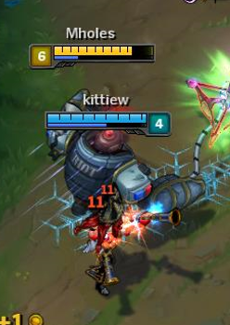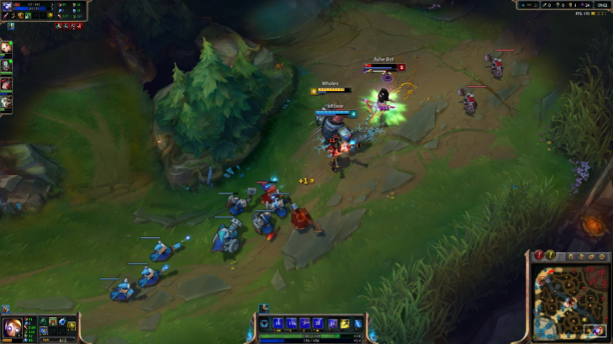

|  |  |
| --- | --- |
| Attributes | Functions |
| _health = 938  _armor = 47  _magicresist = 46  _attackspeed = 0.84  _damage = 91  _abilitypower = 0  _speed= 330  _criticalchange= 0 | Attack()  Die()  Rocketgrab()  Overdrive()  Powerfist()  StaticShield()  Flash()  Exh()  Recall() |

|  |
| --- |
| Object = Blizcrank |

|  |  |
| --- | --- |
| Attributes | Functions |
| _health= 110  _armor= 36  _magicresist= 35  _attackspeed= 0.77  _damage = 83  _abilitypower= 0  _speed= 227  _criticalchance= 0 | Attack()  Die()  RangersFocus()  Volley()  Hawkshot()  EnchantedCrystelArrow()  Flash()  Heal()  Recall() |

|  |
| --- |
| Object = Ashe |

|  |  |
| --- | --- |
| Attributes | Funcions |
| _regenshealth= 5  _totalhealthregen= 165  _seconds= 16.5 | Eaten()  Sell()  Refund() |

|  |
| --- |
| Object= total biscuit of regunivation |

https://i.gyazo.com/14b39927a42965729140ae15b00f1e32.pnghttps://i.gyazo.com/bb974bfa0adbe39523405461d1217183.png

|  |  |
| --- | --- |
| ***OBJECT=*** | ***RYU*** |
| **ATTRUBUTES** | **FUNCTIONS** |
| _health = 95 | Attack() |
| _speed = 20 | Die() |
| _damage = 10 | Jump()  Crouch()  Shoot() |

|  |  |
| --- | --- |
| ***OBJECT=*** | ***KEN*** |
| **ATTRUBUTES** | **FUNCTIONS** |
| _health = 60 | Attack() |
| _speed = 0 | Die() |
| _damage = 10 | Jump() |
|  | Crouch()  Shoot() |

|  |  |
| --- | --- |
| ***OBJECT=*** | ***Fireball*** |
| **ATTRUBUTES** | **FUNCTIONS** |
| _damage = 20  _speed = 30 | Attack()  Die() |

|  |  |
| --- | --- |
| Object | gun |
| Attributes | Function |
| _Shotgunshells = 14  _Bullets =42 | Shoot()  Reload() |

|  |  |
| --- | --- |
| ***Object*** | ***Doomguy*** |
| **Attributes** | **Function** |
| _arms = 2  _armor = 0  _health = 59 | Shoot()  Attack()  Die() |

|  |  |
| --- | --- |
| ***Object*** | ***Enemy*** |
| **Attributes** | **Function** |
| _health =100  _armor =0 | Attack()  Die() |

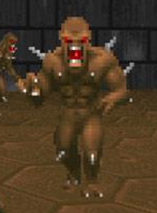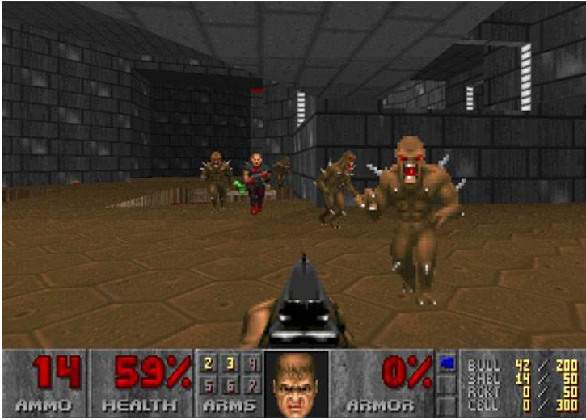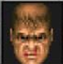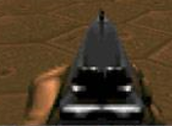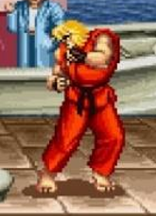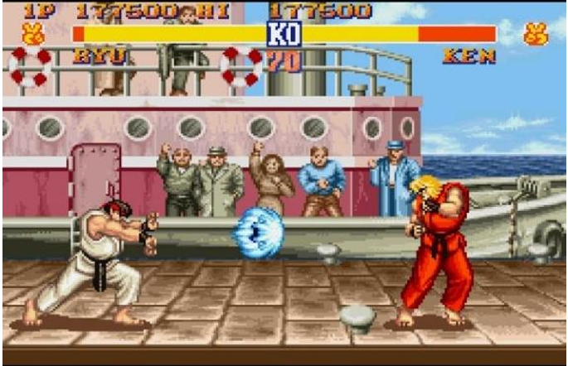

|  |  |
| --- | --- |
| ***Object*** |  |
| **Attribute** | **Function** |
| _health =1  _spirte=  candy | Die()  Fall() |

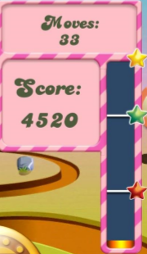https://i.gyazo.com/8f4478441d34f28d08ae192fe12155d7.png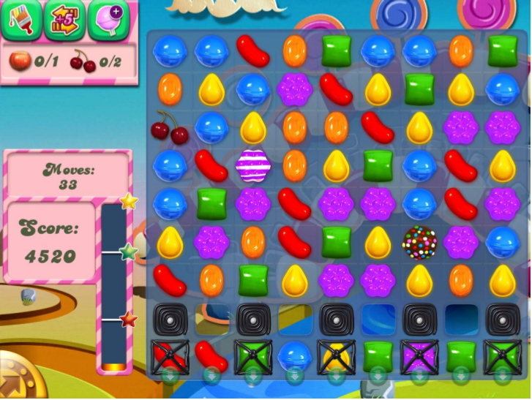

|  |  |
| --- | --- |
| ***Object*** | ***Scoreboard*** |
| **Attribute** | **Function** |
| _score = 4520  _moves = 33 | ShowScore()  ShowMoves() |



|  |  |
| --- | --- |
| ***Object*** | ***Abilities*** |
| **Attributes** | **Function** |
| _Cherry = 0  _hazelnut = 0  _Sprite = Powerups | 5extramoves()  SmashACandy()  PaintStripe() |

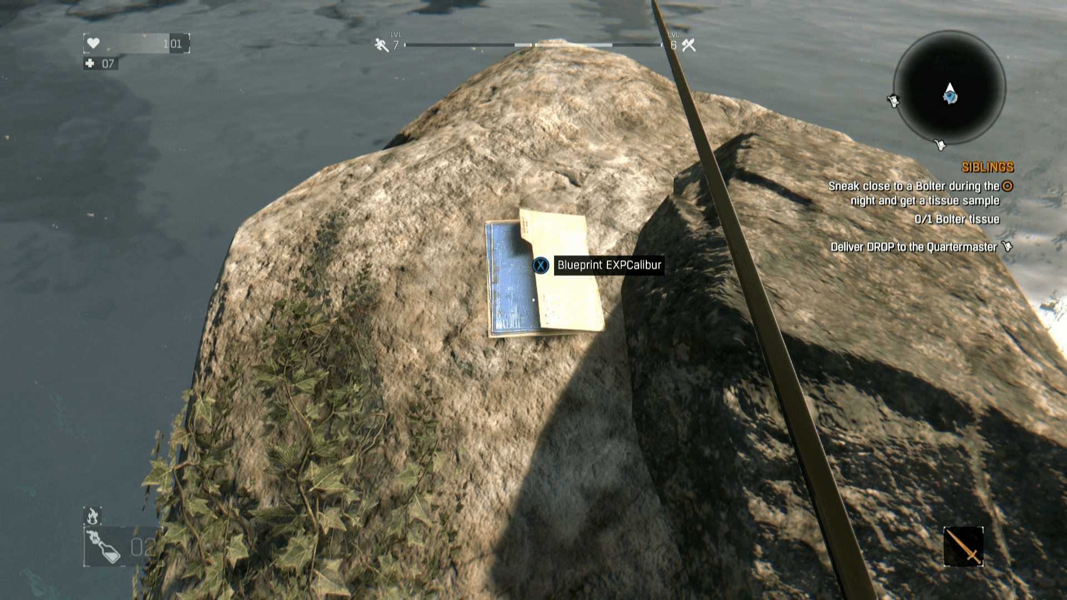

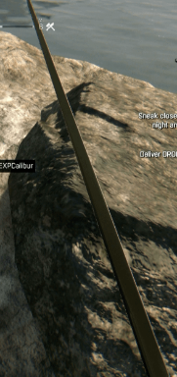***Object= EXPcalibur***

**Attribute Function**

_damage=328 Attack()

_durability=7 break()

_handling=56 repair()

_upgrades=0

_value=14444

_sprite=sword

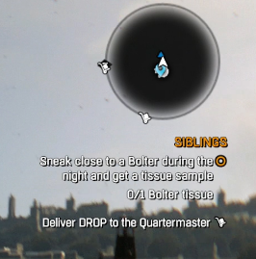

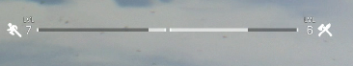***Object = Xp/progress bar***

**Attribute Function.**

|  |  |
| --- | --- |
| Object | Quests+minimap |
| **Attributes** | **Functions** |
| _BolterTissue=0  _Radius=500 | ShowProgress()  ShowWaypoint() |

_Agility=6 ShowAgilitylvl()

_Combat=7 ShowCombatLvl()

_survival=6

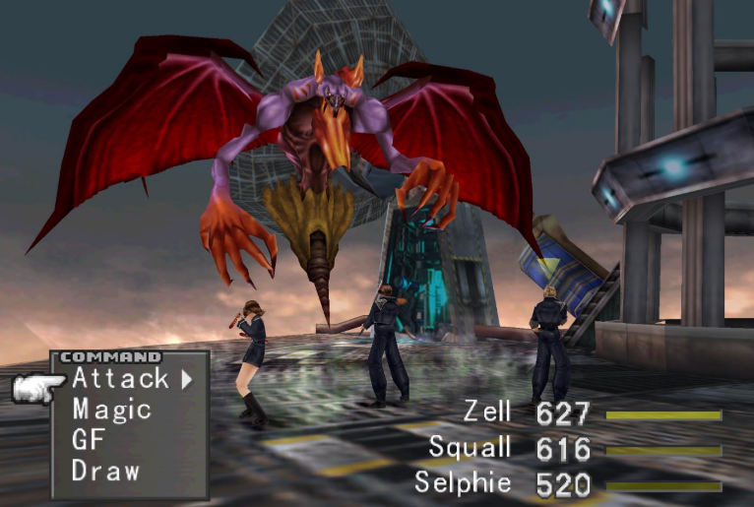

|  |  |
| --- | --- |
| ***Object*** | ***Zell*** |
| **Attribute** | **Function** |
| _health =627  _sprite =Zell | Attack()  Magic()  GF()  Draw() |

|  |  |
| --- | --- |
| ***Object*** | ***Sophie*** |
| **Attribute** | **Function** |
| _health =520  _sprite = Sophie | Attack()  Magic()  GF()  Draw() |

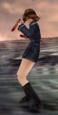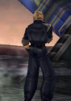

|  |  |
| --- | --- |
| ***Object*** | ***Squall*** |
| **Attribute** | **Function** |
| _health =616  _sprite= Squall | Attack()  Magic()  GF()  Draw() |

